***WEEK- 2***

1. Implement a Python program to sort a list of dictionaries using Lambda. Original list of dictionaries : [{&#39;make&#39;: &#39;Nokia&#39;, &#39;model&#39;: 216, &#39;color&#39;: &#39;Black&#39;}, {&#39;make&#39;: &#39;Mi Max&#39;, &#39;model&#39;: &#39;2&#39;, &#39;color&#39;: &#39;Gold&#39;}, {&#39;make&#39;: &#39;Samsung&#39;, &#39;model&#39;: 7, &#39;color&#39;: &#39;Blue&#39;}]

Code-

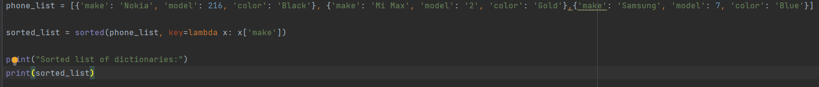

Output-



1. Create a Python function that accepts a string and calculate the number of upper case letters and lower case letters.  Sample String : &#39;The quick Brow Fox&#39;

Code-

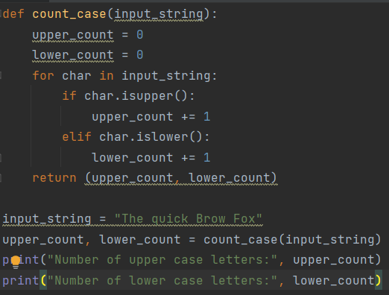

Output-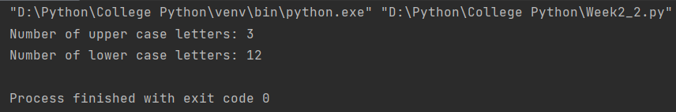

1. Write a Python program to move all zero digits to end of a given list of numbers.

Expected output:

Original list: [3, 4, 0, 0, 0, 6, 2, 0, 6, 7, 6, 0, 0, 0, 9, 10, 7, 4, 4, 5, 3, 0, 0, 2, 9, 7, 1]

Code-

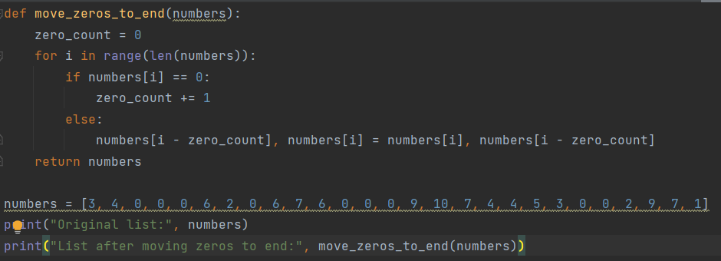

Output-

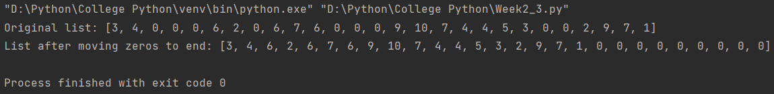

1. Create a Python script to print a dictionary where the keys are numbers between 1 and

15 (both included) and the values are square of keys.

Sample Dictionary:

{1: 1, 2: 4, 3: 9, 4: 16, 5: 25, 6: 36, 7: 49, 8: 64, 9: 81, 10: 100, 11: 121, 12: 144, 13: 169,

14: 196, 15: 225}

Code-

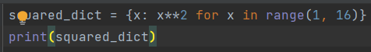

Output-

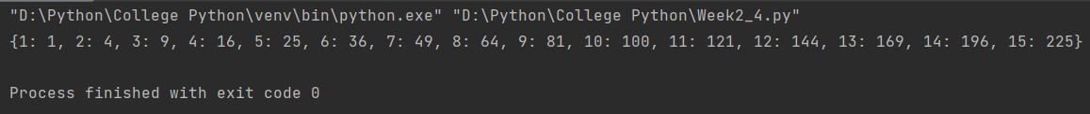

1. Write a Python program to find the numbers of a given string and store them in a list,

display the numbers which are bigger than the length of the list in sorted form. Use

lambda function to solve the problem.

Original string: sdf 23 safs8 5 sdfsd8 sdfs 56 21sfs 20 5

Numbers in sorted form: 20 23 56

Code-

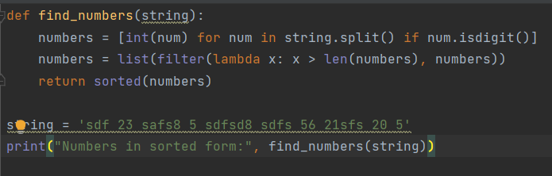

Output-

